http://pesquisa.b-on.pt/V/62NQI2145Y4C7YKM5Q5P219XXIE7X12K5G1GH4LK2PBTA69TT2-16879?func=meta-1&mode=advanced
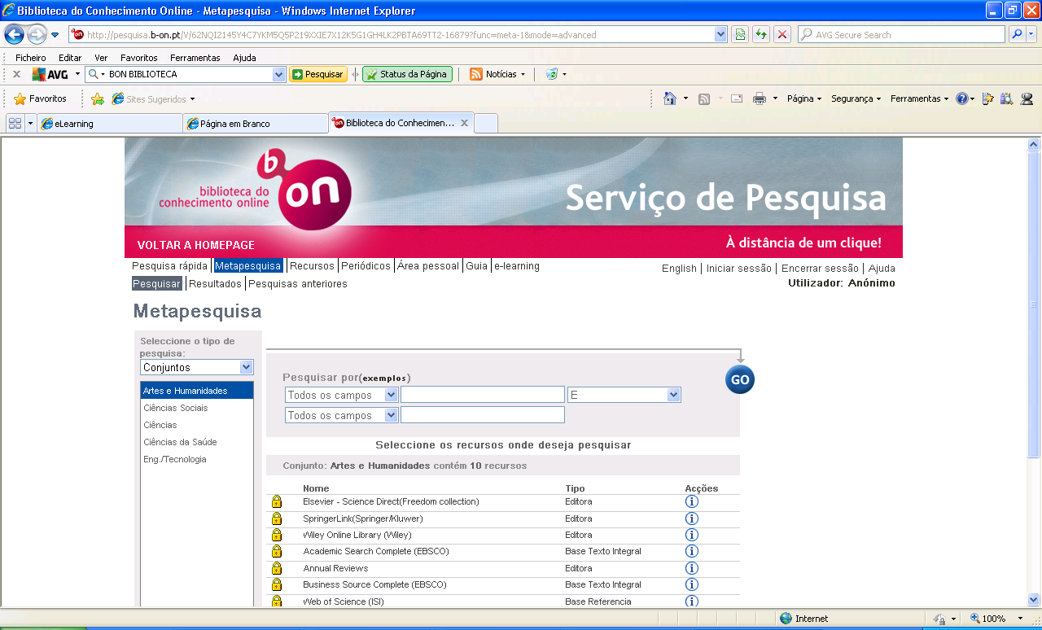
http://onlinelibrary.wiley.com/advanced/search
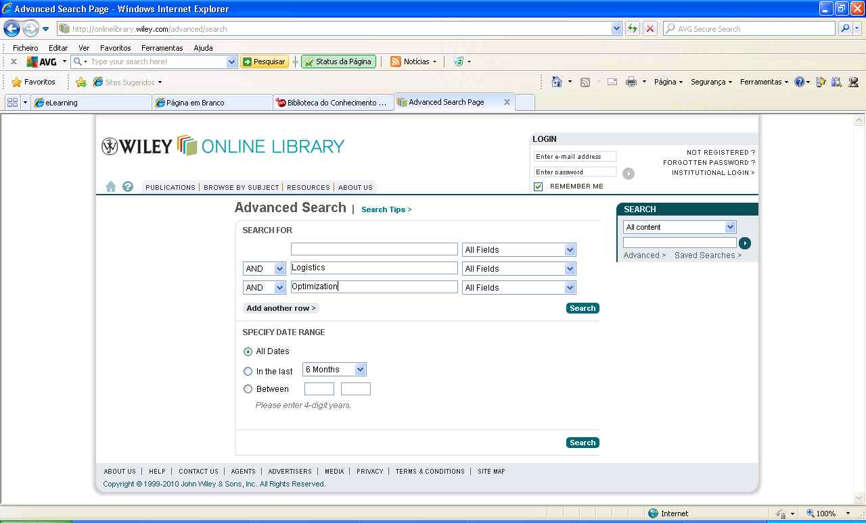

http://www.informaworld.com/smpp/search~db=all~searchmode=advanced?newsearch=true
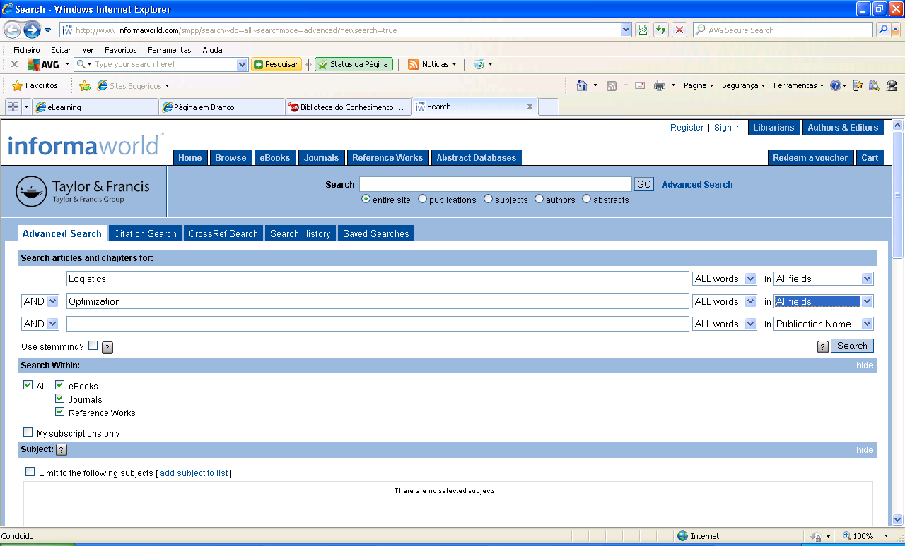
http://www.sciencedirect.com/
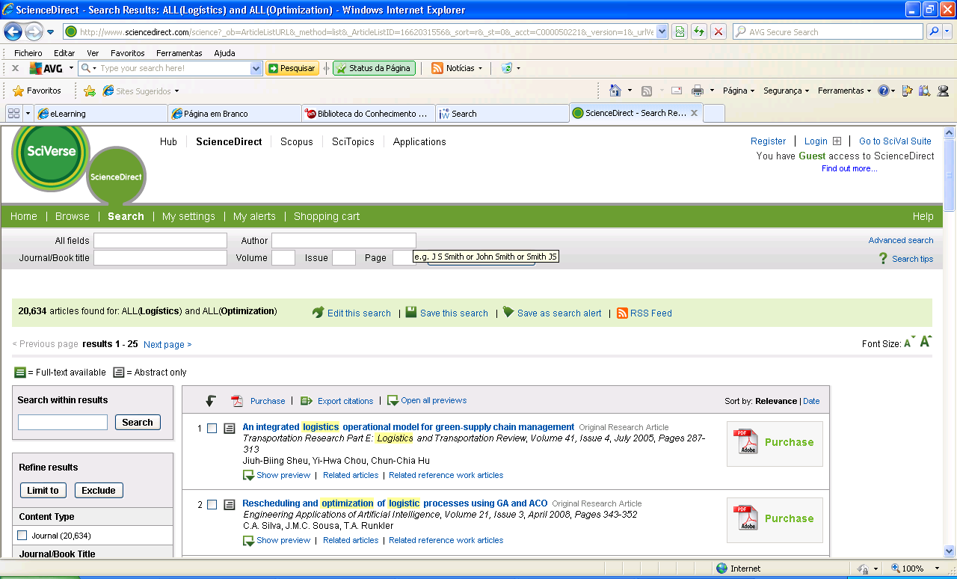
http://www.springerlink.com/home/main.mpx
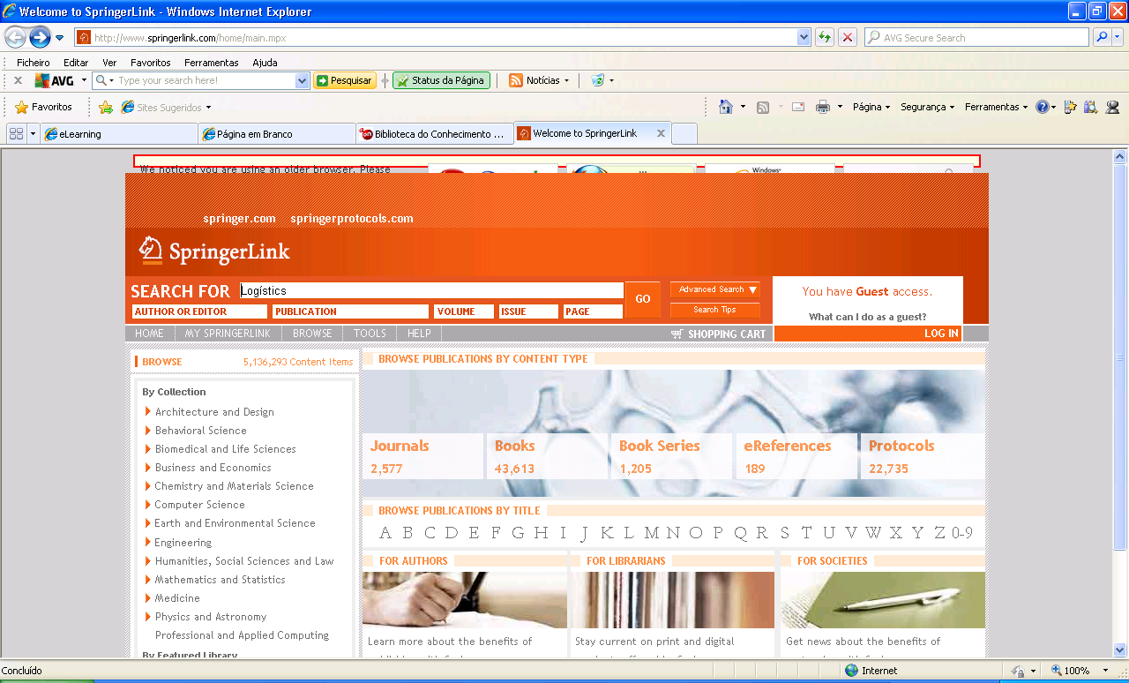
http://ieeexplore.ieee.org/Xplore/dynhome.jsp
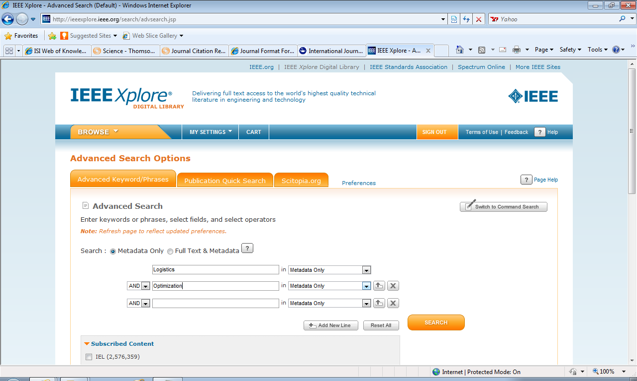
http://www.springer.com/librarians/e-content/ebooks?SGWID=0-40791-12-377411-0

